A data-driven approach to evaluate spatial growth zonation, with application to NE Pacific Sablefish

Kapur, M., Haltuch, M., [others] Punt, A.

Keywords: growth, von Bertalanffy, stock assessment, sablefish, spatial variability

# Abstract

Renewed interest in the estimation of spatial variation in fish body size is a result of computing advances and the development of spatially-explicit management frameworks. However, many attempts to quantify spatial structure or distribution of traits utilize *a priori* approaches, which involve pre-designated geographic regions and thus cannot detect unanticipated trends. This study presents a new, data-driven method which evaluates the first derivative of the spatial smoothing term of a generalized additive model to identify spatial break points in fish length-at-age. We use simulation testing to illustrate the robustness of the method across a variety of spatially stratified age and length data, and apply it to survey data for Northeast Pacific sablefish (*Anoplopoma fimbria*). Preliminary results indicate that some parameters of the von Bertalanffy growth function show an increase with latitude in the NE Pacific, which is consistent with work from the western United States; simulation testing illustrates the robustness of the method across a variety of scenarios related to spatially complex growth data, including strict boundaries, overlapping zones and changes at the extreme of the range. This method has the potential to improve detection of large-scale spatial patterns in fish growth, and aid in the development of structured population dynamics models.

# Introduction

Renewed interest in the development of spatially-explicit management frameworks (e.g. Thorson et al., 2015), and advances in computing power have motivated efforts to quantify spatial variability in fish size for managed species, including Gulf Sheepshead (Adams et al., 2018) and northern rock sole (Hurst and Abookire, 2006), as well as groundfish off the US West Coast (Gertseva et al., 2017; James et al., 2002; Mason et al., 1983). Understanding demographic variation of this key trait (somatic growth) can improve the precision of fisheries assessment (Punt, 2003; Stawitz et al., 2019).

Fish somatic growth rates are typically modelled using the von Bertalanffy growth function (VBGF, von Bertalanffy, 1957) or an alternative functional form, with parameters estimated using model-fitting procedures. The spatial resolution of the resultant estimates is necessarily predicated on the aggregation of the data, which is often defined by survey stratification and/or changes in sampling gear. For example, Alaska federal and state sablefish fisheries estimated separate VBGF parameter estimates for two periods of survey data based on the *a priori* hypothesis that changes in gear type would affect fish growth estimates from survey data (Echave et al., 2012; Hanselman et al., 2017; McDevitt, 1990), and imposed a time block between which estimates of the growth curve parameters were actually quite similar (see Table 2). Even more sophisticated approaches that utilize hierarchical Bayesian methods to estimate latitudinal and regional effects on length- or weight-at-age require a design matrix of dimensions dictated by pre-supposed zones (Adams et al., 2018). Such approaches are useful within a rigid management context, but do not represent the underlying growth process explicitly, and preclude the discovery of spatially-structured trends in fish size that violate management boundaries.

Attempts to quantify spatial variation in somatic growth typically face a trade-off between superimposing previous beliefs about stock structure (as in the Alaskan example above) or generating purely descriptive models of trait ‘gradients’ across regions or time periods, without a clear method to define significant break points within them (refs). This presents a gap for scientists, who wish to develop population dynamics models that accurately represent the population structure of managed stocks. The ideal tool is a data-driven method that defines significant break points in fish size, which researchers can then use to aggregate and estimate parameters of somatic growth, and other quantities of management interest. Our method, which evaluates the first derivative of smooth functions from a generalized additive model (GAM), meets this objective in a simple, rapid computational framework. Researchers are likely already familiar with GAMs, and the method does not require the specification of multiple error structures nor the construction of spatial meshes, which can be computationally expensive when large (Thorson, 2019a). The analysis of first derivatives in GAMs for change-point analysis has recently used in terrestrial paleoecology (Simpson, 2018) and geophysics (Beck et al., 2018). The objective of this study was to develop a method for detecting change points in spatially structured fisheries growth data that minimizes the use of pre-supposed spatial stratifications. This method has the potential to improve detection of large-scale patterns in fish growth, and aid in the development of spatially structured population dynamics models. We use simulation to test the robustness of the method for spatially structured age-length data of varied complexity, and present a case study application to northeast Pacific sablefish (*Anoplopoma fimbria).*

Sablefish (*Anoplopoma fimbria*) are a highly mobile, long-lived, valuable groundfish that have high movement rates (10 – 88% annual movement probabilities across Alaska, Hanselman et al. 2015) and range from Southern California to the Bering Sea. Concurrent population declines across the entire range during the past few decades have increased concern about the status of sablefish and interest in the causes of the downward trend. Traditionally, sablefish stock assessment and management has occurred independently at regional scales, namely Alaska, British Columbia, and the US West Coast, assuming that these are closed stocks. However, recent genetic work has shown that NE Pacific sablefish are not genetically distinct between these traditional management areas (Jasonowicz et al., 2017), though there is evidence for differences in growth rate and size-at-maturity throughout the range (McDevitt, 1990). This suggests that the current delineation of assessment and management regions is incongruent with the stock’s actual spatial structure and motivates research that would enable the construction of a population dynamics model that represents the spatial heterogeneity of sablefish throughout their range. Results from this work will inform the construction of a spatially-explicit operating model for sablefish, which

# Methods

## Method Summary

The method involves fitting a Generalized Additive Model (GAM) using the mgcv package (Wood, 2011) in R (R Development Core Team, 2011) to the vector of observed lengths of age-six fish as the response variable, predicted by separate smoothers for year and latitude., i.e.

Equation 1

where µt represents the expected mean of fish length, which is a random variable of which we have *t* observations; the linear effects of latitude () and year (), the last two of which are smooth functions. *g* is an invertible, monotonic function that enables mapping from the response scale to the scale of the linear predictor, such as the natural logarithm. To simplify the analysis, we fit the GAM to a subset of each simulated datasets including only female fish of age six (thus precluding the need to control for age or sex).

The first derivatives of the GAM with respect to latitude and longitude are evaluated to identify areas of significant change (i.e., break points) in fish size, which is taken as a proxy for zonal differences in fish growth. The equations below provide an example using latitude , but the process is repeated for each smoother. The finite differences method (as in Simpson, 2018) approximates the first derivative of the spline generated from the GAM function. For instance, the vector of derivatives **G** for latitude is produced via:

Equation 2

where is a vector of predicted lengths at latitudes , defined by the user as ( = 0.001 in this analysis) with other effects (year, longitude) held constant. Therefore, the numerator of **G** is the difference between the predicted and observed length over latitudinal interval , which is necessarily small. Vector **G** is of the same length of the observed dataset.

The uncertainty in derivative estimates are computed as:

Equation 3

where **V** is a 1x1 covariance matrix for each of parameters of the current GAM spline (typically just one); the square root provides the standard error for each derivative estimate of the spline. These steps are then repeated for years and longitudes for the data set at hand. For each parameter, we identify where the maximum absolute value of the first derivative is obtained; this is rounded to the nearest integer and defined as the “break point” as long as its 95% confidence interval does not include zero. Figures 1 and 3 illustrate the raw data, smoothers and first derivatives thereof for two sample dataset. Once identified, the raw length and age data (including all ages of fish) are re-aggregated to match the breakpoints and the parameters of the VGBF (*L∞* - asymptotic length, *k* - the rate at which asymptotic length is approached and *t0* - the estimated age at length zero) estimate using maximum likelihood in Template Model Builder (Kristensen et al., 2016) under the assumption that the error is normally distributed with zero mean and variance σ.

Equation 4 2)

The growth curve was fitted separately for each sex, resulting in estimated values for the three growth parameters for each spatiotemporal stratum by sex; For all runs, initial parameters were *t*0 = 0.1, = 0.1, with *L*∞ = 150cm, *k* = 0.1.

## Simulation Testing

We performed a simulation study to evaluate the performance of the proposed method, using datasets generated using an individual-based model (IBM). The IBM (See Appendix for full details of IBM.) is capable of mimicking individual characteristics by following the life history processes (survival, growth, and reproduction) of individual fish. We simulate spatial variation by generating length and age datasets under different growth regimes (e.g. higher values of *K* and ) and assign a range of latitudes to each regime. The IBM implements the VBGF using Schnute’s formulation of the VGBF, which requires (*k*, *L*1, *L*2) so is computed as:

Equation 5 =

where represent the lengths of a fish at ages /, and *k* is the Brody growth parameter as before. An individual fish’s annual growth increment is subject to a bias-corrected lognormal error term. Depending on the scenario, different growth ‘Regimes’ (defined as distinct and/or values) are either assigned completely distinct latitudinal ranges or ranges with some overlap. To simulate spatial zones, fish locations were sampled from a uniform distribution with boundaries specific to a certain growth Regime. Regime 1 refers to a central Pacific billfish-like species, where *L*1 = 62.69 and = 216.72cm; in Regime 2 *L*1= 50cm and = 350cm; in Regime 3, which was designed to be low contrast compared to Regime 1, =50cm, and .

The simulation scenarios described in Table 1 were designed to represent a variety of possible regimes in spatial growth variation. In all except the final (break at edge) and non-spatial scenarios, the latitude and longitude of fish grown under Regime 1 are sampled independently and at random from a uniform distribution between 0° and 25°; for simulations with spatial variation, fish grown under Regimes 2 and 3 have latitude and longitude sampled the same way from 25° to 50°. In the final scenario, fish simulated under life history Regime 1 are assigned latitudes and longitudes sampled independently and at random from a uniform distribution from 1° to 49°, and those simulated under Regime 2 have coordinates sampled similarly with both latitude and longitude bounded from 49° to 50°. Under each scenario, we generated 100 replicate datasets which averaged 439 age-six fish per dataset, and tabulated the frequency at which a given (true) break point was identified using the method described above. The method was evaluated based on: a) if it was able to accurately detect the presence or absence and location of ‘break point(s)’ in space, and b) the coverage probability of VGBF parameter estimates when data were re-aggregated at the proposed break point. Figure 1 illustrates the latitudinal distribution of age-six fish for an example of one simulated dataset (of 100) under each scenario.

## Application to Northeast Pacific Sablefish **– THIS HAS NOT BEEN UPDATED!**

Estimates of the parameters of the growth curve for sablefish are usually based on survey data acquired from chartered commercial trawl or longline vessels (Table 1). It is preferable to obtain estimated growth parameters using data from a survey, because fishery-dependent information can be heavily biased due to targeting or gear selectivity (Ricker, 1969).

We obtained fishery-independent length and age data from the Alaska Sablefish Longline Survey and the U.S. West Coast Groundfish Bottom Trawl Survey conducted annually by the Alaska Fisheries Science Center and Northwest Fisheries Science Center, respectively. We also obtained length and age records from the Canadian Department of Fisheries and Oceans, which has performed an annual trap-based survey since 1991. Data from each region included measured length, sex, age, and the starting latitude and longitude which determined the survey station. Due to computational constraints, and to avoid disproportionate influence of more heavily-sampled regions, we randomly subsampled 15,000 total records from each of the three management regions. This produced a data set with 856, 659 and 784 age-four sablefish from the West Coast, British Columbia and Alaska, respectively

In constructing the GAM, we investigated the use of an AR1 temporal structure with lags of 1 to 3 years, but these models did not improve AIWC over the initial model without autoregressive structure.

Our model estimates values for the three biological parameters at each spatiotemporal strata for two sexes; the additive error term is assumed universal across strata and sex and normally distributed with mean zero.

# Results

## Simulation Study

The simulation study demonstrated that the first-derivative method was able to detect the correct spatial breakpoint, and did so more frequently than erroneous locations. Figure 1 shows an example data set for each of the scenarios presented in Table 1, and Figures 1 and 3 show smoothers and breakpoints identified for two sample datasets from two tested scenarios.

Table 2 presents the most-frequently detected break point across 100 simulated datasets for each scenario (i.e. the mode). None of the three fixed break points (at 25, 30, and 49 degrees) were detected in more than 30% of simulations, but the correct break points did constitute the most frequently detected location. For the overlapping ranges between 20° and 25° Latitude, the most commonly detected break point was at 23°; the histogram of detected points shows a cluster of break-point detection spread across the overlapping range (Figure 4, leftmost column). Because the detection method coerces breakpoint estimates to the nearest integer, it is likely this represents the ‘true’ midpoint of 22.5°. It correctly recognized zero break points in 84% of simulated datasets without spatial structure.

After re-aggregation to the most commonly detected break point (which was universally the correct one), the estimated mean and confidence interval for both growth parameters overlapped with the values used to generate the dataset (Figure 1, central column). The predicted VBGF produced a visually good fit to the simulated data (Figure 1, rightmost column) for all scenarios across both regimes.

## Application to NE Pacific Sablefish **– THIS HAS NOT BEEN UPDATED!**

Our best-fit GAM produced a positive definite Hessian and converged after 10 iterations. It explained 42.4% of deviance. The latitude smoother suggested a generally increasing cline in length-at-age six with latitude, with a significant breakpoint centered around 49˚N (approximately Vancouver, Canada), which corroborates results in Gertseva et al. (2017). The temporal smoother did not exhibit a strong one-way trend, though the quantile analysis identified a significant change in slope centered on years 2004-2005 (Figure 3). We therefore split the data collected during or after 2005 (hereafter referred to as “late”; prior data is “early”) and at 49˚N (hereafter referred to as “north”; data collected south of this point is designated as “south”). Parameter estimation in TMB for the VBGF generated estimates for mean and standard deviations of *t0*, log(*k*) and log(*L∞*) for unique combinations of north/south, early/late and male/female populations, and associated predictions for length at age (Figure 4). The error term was estimated to be 6.13 (standard deviation = 0.027). Across spatiotemporal strata and sexes, there was considerable overlap in parameter estimates for the growth rate *k,* whereas *L∞* and its confidence intervals were spread out at the stratification indicated by the GAM derivative analysis (Figure 5).

# Discussion

## Simulation study

### Caveats of Approach

One notable weakness of the GAM approach is the model’s sensitivity to the penalty function, often referred to as λ, which controls the degree of smoothness of the spline and, when unchecked, can lead to overfitting. Since the purpose of this analysis was diagnostic (the detection of where the spline is changing the most), we were able to avoid undue influence from this parameter by a) selecting only the maximum first derivative and b) disregarding values whose confidence interval contained zero, which was common in highly curved splines. Additionally, the fitting method could have been improved by either performing the spatial and temporal analyses in a stepwise fashion, or by re-aggregating the data to include an early and late stratum for each spatial zone. Finally, we did not consider movement of fish between regions. Future iterations of this work will likely do so.

## North Pacific Sablefish

It is evident from this and previous work (Echave et al., 2012; Gertseva et al., 2017; McDevitt, 1990) that there is some level of variation in sablefish growth, whether in the growth rates themselves or the spatiotemporal scale at which growth anomalies oWCur. Mis-specification of growth within stock assessment can lead to overestimation of management quantities, particularly the estimate of stock depletion (Stawitz et al., 2019). Correctly-specified growth in the estimation model can reduce uncertainty by correctly attributing process error to somatic growth anomalies. The purpose of this study was to define the ideal spatiotemporal scale at which to structure growth for future use in a range-wide operating model of sablefish population dynamics.

Previous work with sablefish data has utilized an *a priori* method, wherein length and age data were aggregated into pre-hypothesized spatial zones and fitted VBGF curves were compared via Akaike’s Information Criterion. This ‘information-theoretic’ (Guthery et al., 2003) method is fairly straightforward computationally, and has been implemented separately for the California Current (Gertseva et al., 2017) and Alaska federal and state sablefish fisheries (Echave et al., 2012; McDevitt, 1990). The WC analysis identified a statistically significant break in von Bertalanffy growth parameters for sablefish at approximately 30 degrees N, between Point Conception and Monterey, CA, with additional evidence for an increasing cline in *L*∞ with increasing latitude. That work also found an increase in *k* estimates for populations sampled in the Vancouver region (ca. 49˚N), which was posited to be the result of samples coming from the “southern end of a faster-growing northern stock”, a suggestion supported by our findings. The authors of that study described how sablefish have been shown to be highly migratory, with ontogenetic movements off the coastal shelf; such combined, complex life patterns could yield higher growth rates in northern regions that interact with a more generalized shelf-slope pattern observed in groundfish overall. For Alaska, a generalized linear model of length as a function of pre-specified zones and time blocks was used to diagnose a ‘regime change’ in sablefish growth oWCurring in 1995, though the authors explain this shift is possibly attributable to changes in sampling strategy that oWCurred in that year’s survey. In the recent AK sablefish assessments, the parameters of the VBGF are time-blocked aWCordingly (see Table 1) despite caution that the change is not inherent to the population, but likely an artifact of sampling methods. In our analysis (which included data for all regions), the first derivative was not zero in 1995 though it was not of enough magnitude to pass the quantile filter. **[Further discussion of sablefish movement following tagging analyses by Luke Rodgers, DFO postdoc].**

The consideration of temporal variation in sablefish growth is further complicated by the exploitation history of the fishery, which has steadily marched north- and west-ward over the last several decades, encountering ‘larger’ fish with subsequent expansion (M. Haltuch, pers. comm.). This suggests that differences in mean length across the region could be attributable to different degrees and durations of fishing pressure, and not inherent population differences alone. Importantly, the L∞ estimates for both sexes and regions show a decline from the ‘early’ to ‘late’ periods, resulting in nearly equivalent values for north and south regions for females and males, respectively. Simulation work by Stawitz et al. (2015) sought to model growth anomalies in sablefish (among other groundfish) as a process driven by variation in either annual, initial size or among cohorts. Data was partitioned between the WC and two regions of Alaska, and it was determined that annual-scale anomalies were more pronounced in the WC whereas the initial normalized length within each cohort explained more variation in Alaska. A principal conclusion was that the form of growth variation differed among ecosystems, wherein the WC is a more climactically variable region, which could explain why annual deviates were best for fitting to this data. Such ecosystem-driven trends may be diluted when analyzing the data as a composite, as in our study; notably, our temporal smoother did not produce a distinct annual cyclic trend. Methods that consider the space and time components co-dependently (as in vectorized auto-regressive spatio-temporal models, Thorson, 2019) may strengthen the ability to disentangle such trends, and also to consider spatial effects beyond simple latitude (e.g. near- and offshore).

# Figures

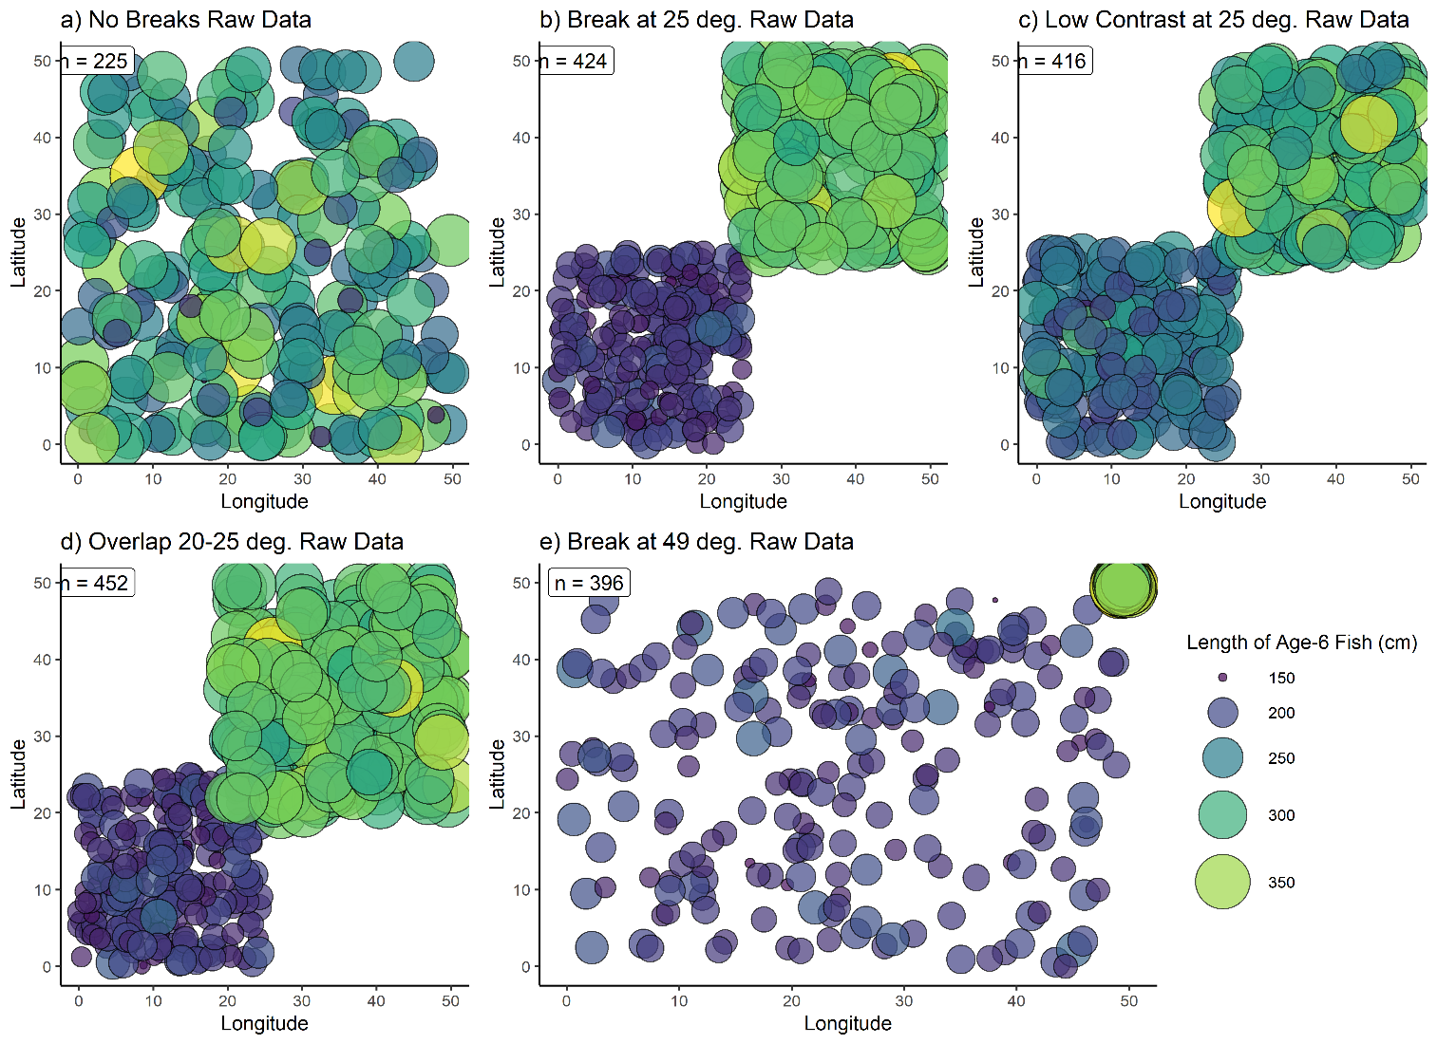

Figure 1. Example single dataset for each tested spatial scenario presented in Table 1. For each scenario, points represent the length and location of a single simulated fish of age six. Fish locations (latitudes and longitudes) were sampled from a uniform distribution of the boundaries indicated in Table 1. Text labels indicate the number of individual fish in the sample.

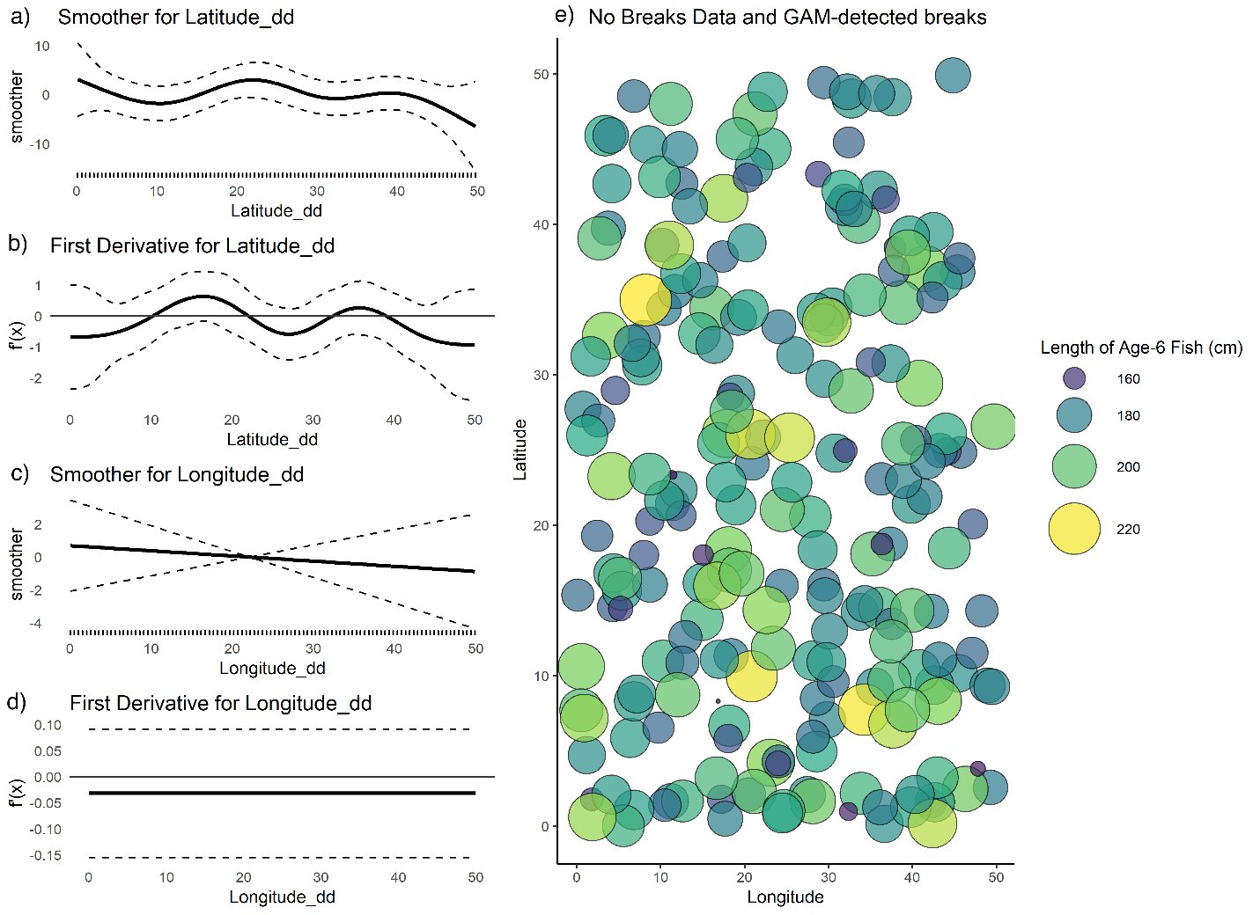

Figure 2. (a,c) raw value of GAM smoothers for Latitude and Longitude; (b,d) mean (black line) and 95% CI (dashed lines) of first derivative of the spatial smoothers; (e) map of age-6 fish for a single simulated dataset with no designated spatial breaks. No break points were detected by the GAM.

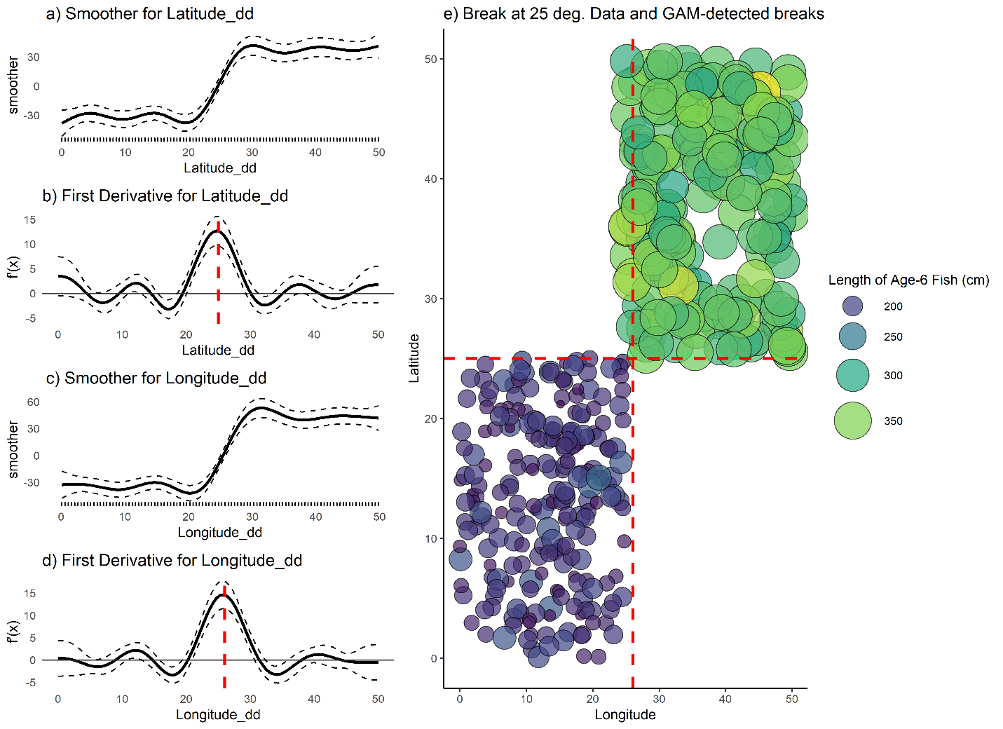

Figure 3. (a,c) raw value of GAM smoothers for Latitude and Longitude; (b,d) mean (black line) and 95% CI (black dashed lines) of first derivative of the spatial smoothers; (e) map of age-6 fish for a single simulated dataset with no designated spatial breaks. Vertical dashed red lines indicate detected break points, which are the maximum value obtained for this data set and may not have a confidence interval that contains zero.

Figure 4. a) coverage probabilities for endpoints of growth curve, L1 (left) and L2 (right), and b) proportion of 100 simulations for each spatial scenario wherein the correct

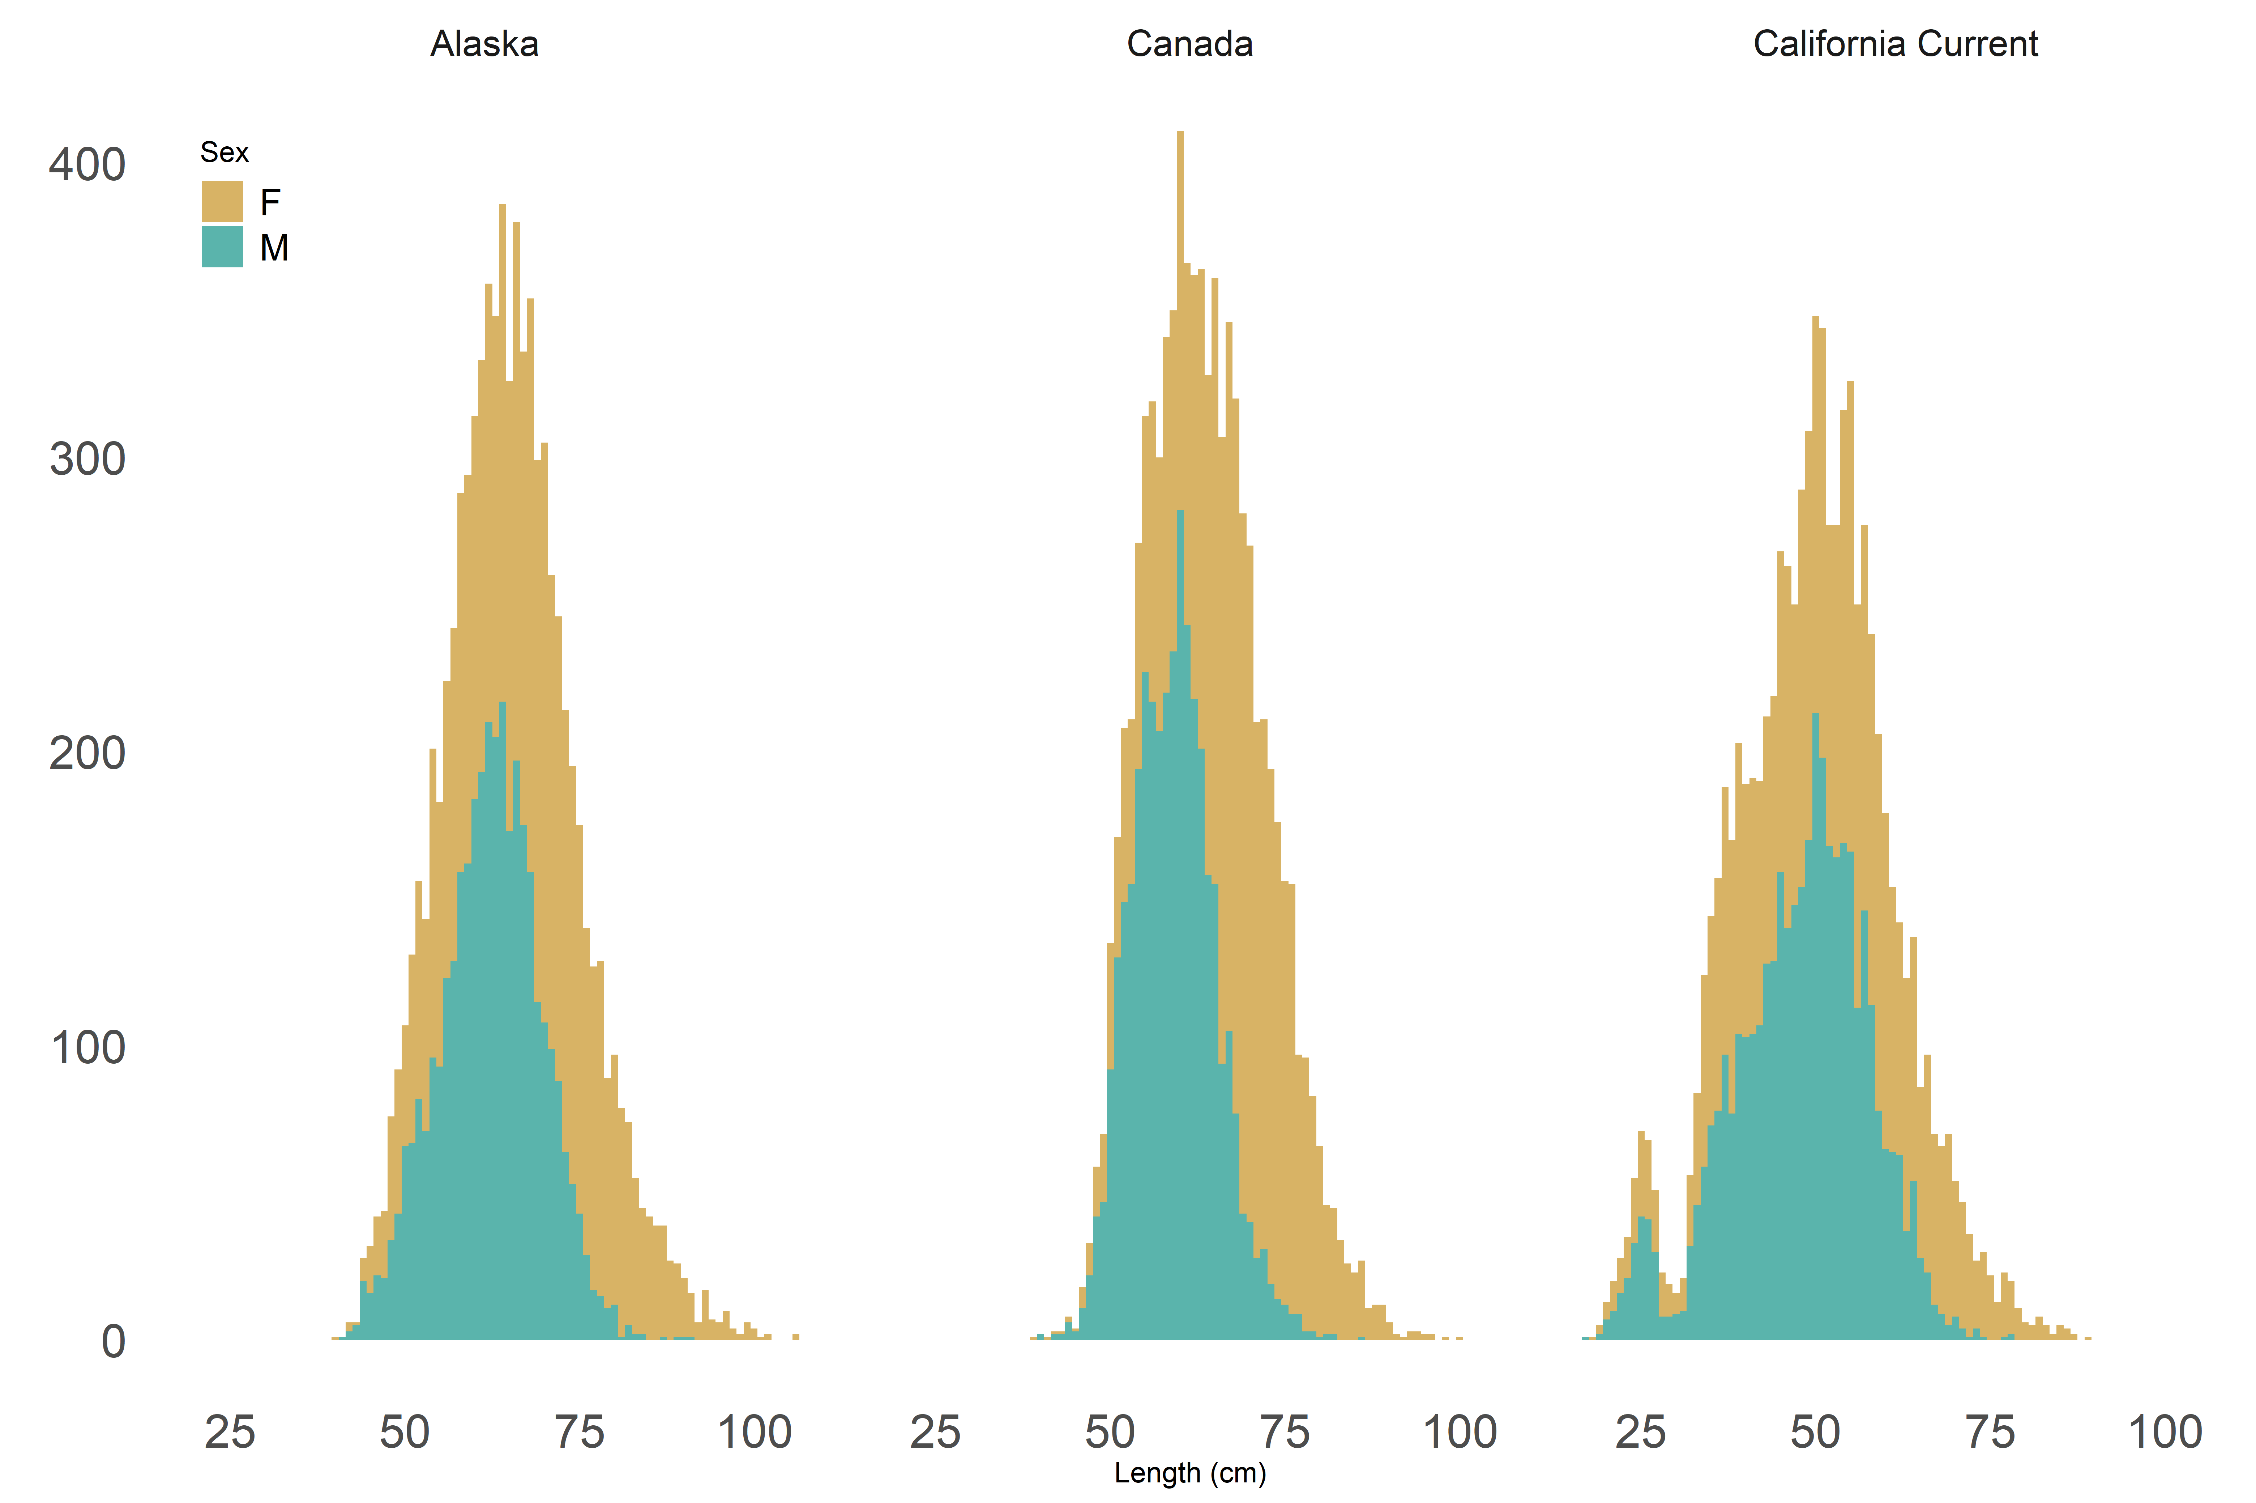Figure 5. Histogram of raw length data from three regional surveys, colored by sex.

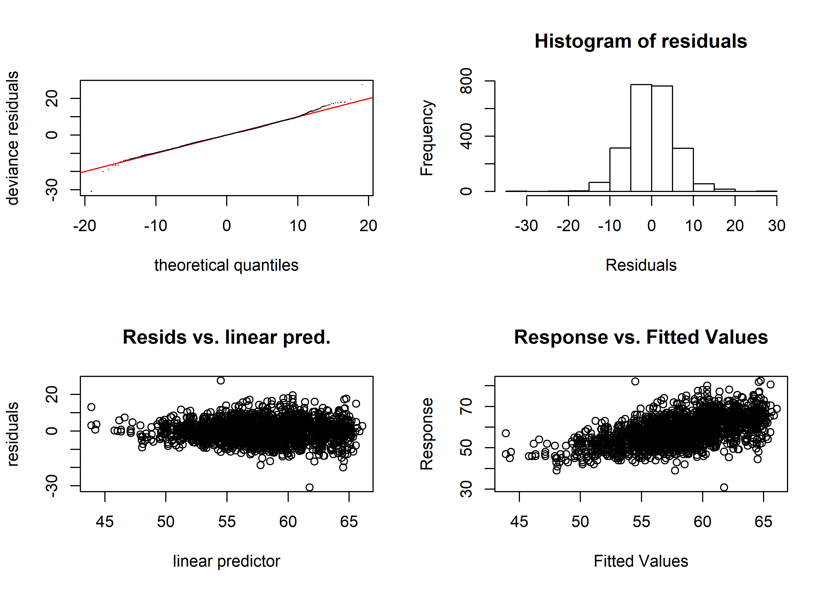

Figure 6. Diagnostic plots of best-fit GAM model for sablefish. Clockwise from top left: quantile-quantile plot of deviance residuals; histogram of residuals; observed response values (lengths, in cm) vs predicted values, and model-predicted residuals vs linear predictor.

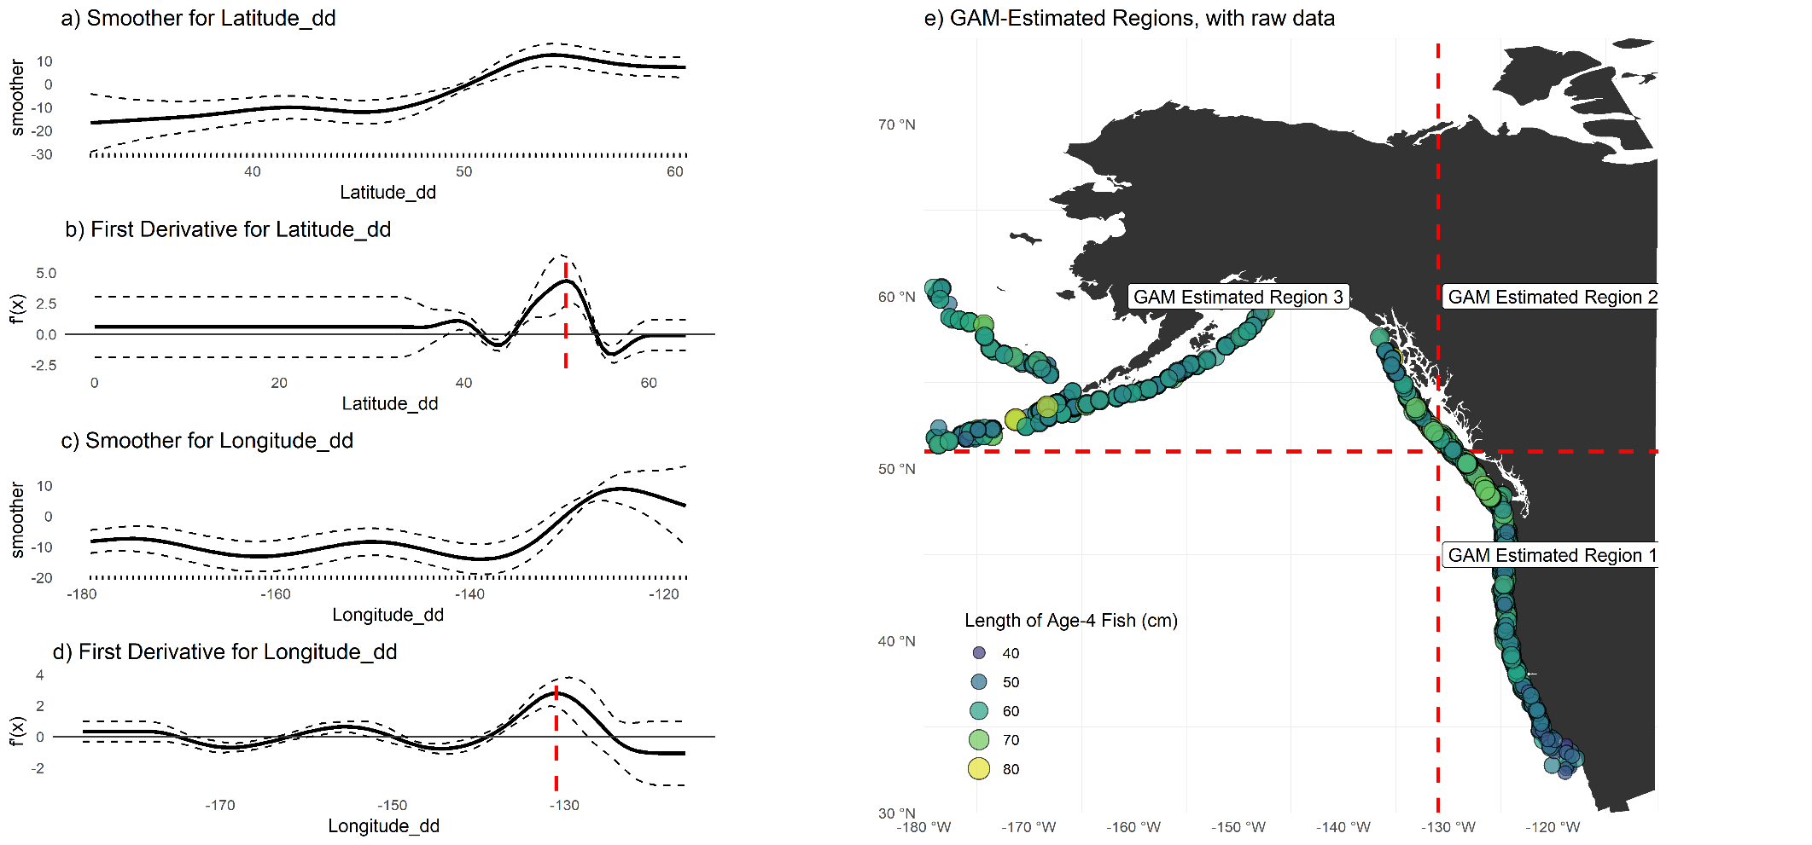

Figure 7. Plots of smoothers for Year and Latitude, and first derivatives thereof. Red lines indicate latitudes or longitudes that produced the highest first derivative and had a confidence interval that did not include zero.

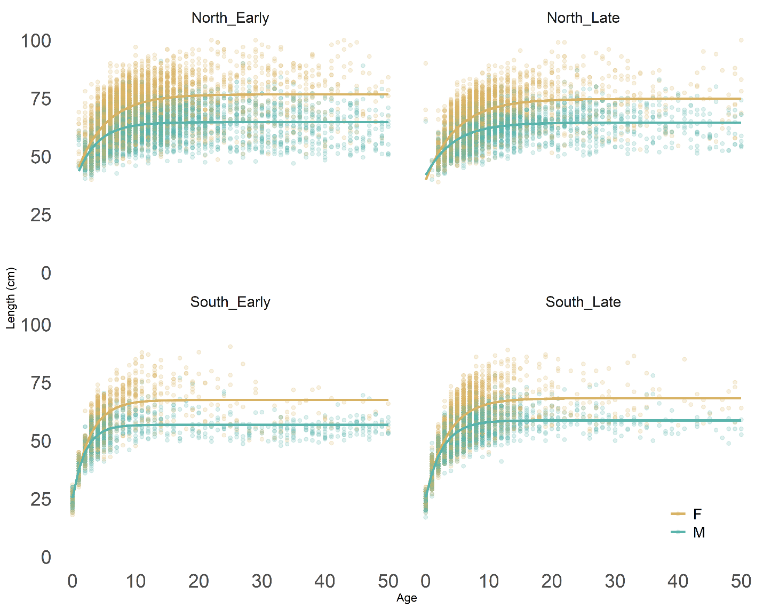

Figure 8. Fits of von Bertalanffy growth function to data stratified at values determined using the derivative analysis of the GAM. Panels marked “early” are data obtained prior to 2005; “Northern” datapoints were collected north of 45˚N latitude. Predicted values are color-coded by sex.

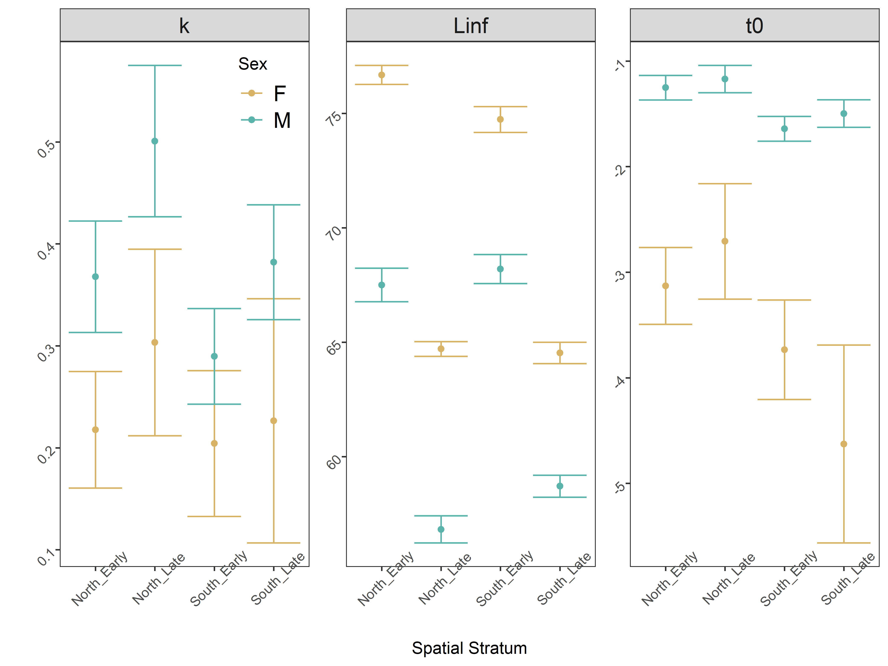

Figure 9. Comparative boxplot of estimated parameters from spatiotemporally stratified data. The error term (not shown) was estimated universally for all regions and sexes.

# Tables

|  |  |
| --- | --- |
| **Scenario Description** | **Spatial Stratification** |
| No spatial breaks | Latitude ~ U[0,50] |
| Single, spatial break in middle of range, with no overlap and strong contrast | Latitude and Longitude ~ U[0,25] under growth Regime 1; Latitude and Longitude ~ U[25,50] under Regime 2 |
| Single, spatial break at 25 degrees with no overlap and reduced contrast | Latitude and Longitude ~ U[0,25] under growth Regime 1; Latitude and Longitude ~ U[25,50] under Regime 3 |
| Single spatial break with some overlap | Latitude and Longitude ~ U[0,25] under growth Regime 1; Latitude and Longitude ~ U[20,50] under Regime 2 |
| Single spatial break at edge of range with no overlap | Latitude and Longitude ~ U[0,49] under growth Regime 1; Latitude and Longitude ~ U[49,50] under Regime 2 |

Table 1. Summary of simulated datasets used to test the proposal method in presence/absence of spatial variation in growth.

|  |  |  |
| --- | --- | --- |
| **Scenario Description** | **True Break Points** | **Most commonly detected break (proportion)** |
| No spatial breaks | None | None (0.84) |
| Single, symmetrical spatial break in middle of range, with no overlap and strong contrast | 25° Latitude and 25° Longitude | 25° (0.24) |
| Single, symmetrical spatial break at 250 with no overlap and reduced contrast | 25° Latitude | 25° (0.30) |
| Single spatial break with some overlap | 49° Latitude | 49° (0.25); tied with 50° |
| Single spatial break at edge of range with no overlap | Between 20° and 25° Latitude | 23° (0.38; 0.92 between 20° and 25°) |

Table 2. Summary of true and most-frequently detected break points following GAM derivative analysis. For each scenario, the most-frequently identified break point is presented, with the proportion of 100 runs which detected this point in parentheses. The distribution of detected break points can be visualized in Figure 1.

|  |  |  |  |  |  |  |  |  |  |
| --- | --- | --- | --- | --- | --- | --- | --- | --- | --- |
| **Region** | **Survey Method** | **Sample size used in this analysis** | | **VBGF parameters from recent assessments** | | | | | |
| **M** | **F** | **L∞** | | **K** | | **t0 (years)** | |
| **M** | **F** | **M** | **F** | **M** | **F** |
| West Coast of US (Johnson et al., 2015) | Trawl on chartered commercial fishing vessels | 4056 | 4183 | 57 | 64 | 0.41 | 0.32 | 0 (fixed) | 0 (fixed) |
| British Columbia | Stratified trap survey | 3725 | 4514 | 68.99 | 72.00 | 0.29 | 0.25 | 32.50 | 32.50 |
| Alaska Federal (Hanselman et al., 2015) | Longline on chartered commercial fishing vessels | 3531 | 4551 | *67.8  ⁑65.3 | *80.2  ⁑75.6 | *0.29  ⁑0.28 | *0.22  ⁑0.21 | *⁑2.27 | *⁑1.95 |

Table 3. Overview of survey methods, data available and most recent VBGF parameters used for sablefish in stock assessments. *Time-blocked VBGF parameters for AK Federal assessment 1996-current; ⁑Time-blocked VBGF parameters from 1960-1995 (Hanselman et al., 2017).

*The WC assessment, which is written in Stock Synthesis, does not specify L∞ nor t0, but instead an age-length key (with values for minimum and maximum length and ages). Values were back-converted for presentation here.

|  |  |  |
| --- | --- | --- |
| Predictor | Estimated Degrees of Freedom | Proposed Breaks |
| s(Year) | 7.984 | 2004, 2005 |
| s(Latitude) | 8.888 | 48˚ to 50˚N |

Table 4. Description of smoothers and values along each where the first derivative lay outside the 5th to 95th percentile.

# References

Adams, G.D., Leaf, R.T., Ballenger, J.C., Arnott, S.A., McDonough, C.J., 2018. Spatial variability in the growth of Sheepshead (Archosargus probatocephalus) in the Southeast US: Implications for assessment and management. Fish. Res. 206, 35–43. https://doi.org/10.1016/j.fishres.2018.04.023

Beck, K.K., Fletcher, M.S., Gadd, P.S., Heijnis, H., Saunders, K.M., Simpson, G.L., Zawadzki, A., 2018. Variance and Rate-of-Change as Early Warning Signals for a Critical Transition in an Aquatic Ecosystem State: A Test Case From Tasmania, Australia. J. Geophys. Res. Biogeosciences. https://doi.org/10.1002/2017JG004135

Echave, K.B., Hanselman, D.H., Adkison, M.D., Sigler, M.F., 2012. Interdecadal Change in Growth of Sablefish (*Anoplopoma fimbria*) in the Northeast Pacific Ocean. Fish. Bull. 110, 361–374.

Gertseva, V., Matson, S.E., Cope, J., 2017. Spatial growth variability in marine fish: Example from Northeast Pacific groundfish. ICES J. Mar. Sci. 74, 1602–1613. https://doi.org/10.1093/icesjms/fsx016

Guthery, F.S., Burnham, K.P., Anderson, D.R., 2003. Model Selection and Multimodel Inference: A Practical Information-Theoretic Approach. J. Wildl. Manage. https://doi.org/10.2307/3802723

Hanselman, D.H., Heifetz, J., Echave, K.B., Dressel, S.C., Jech, J.M., 2015. Move it or lose it: movement and mortality of sablefish tagged in Alaska. Can. J. Fish. Aquat. Sci. 72, 238–251. https://doi.org/10.1139/cjfas-2014-0251

Hanselman, D.H., Lunsford, C.R., Rodgveller, C.J., 2017. Assessment of the sablefish stock in Alaska in 2017. Stock Assess. Fish. Eval. Rep. Groundf. Resour. Gulf Alaska 576–717.

Hanselman, D.H., Lunsford, C.R., Rodgveller, C.J., 2015. Assessment of the sablefish stock in Alaska. Stock Assess. Fish. Eval. Rep. Groundf. Resour. Gulf Alaska 2014, 576–717.

Hurst, T.P., Abookire, A.A., 2006. Temporal and spatial variation in potential and realized growth rates of age-0 year northern rock sole. J. Fish Biol. 68, 905–919. https://doi.org/10.1111/j.0022-1112.2006.00985.x

James, M.K., Armsworth, P.R., Mason, L.B., Bode, L., 2002. The structure of reef fish metapopulations: modelling larval dispersal and retention patterns. Proc. Biol. Sci. 269, 2079–2086. https://doi.org/10.1098/rspb.2002.2128

Jasonowicz, A.J., Goetz, F.W., Goetz, G.W., Nichols, K.M., 2017. Love the one you’re with: genomic evidence of panmixia in the sablefish ( *Anoplopoma fimbria* ). Can. J. Fish. Aquat. Sci. 74, 377–387. https://doi.org/10.1139/cjfas-2016-0012

Johnson, K.F., Rudd, M.B., Pons, M., Akselrud, C.A., Lee, Q., Haltuch, M.A., Hamel, O.S., 2015. Status of the U.S. sablefish resource in 2015.

Kristensen, K., Nielsen, A., Berg, C., Skaug, H., Bell, B., 2016. TMB: Automatic Differentiation and Laplace Approximation. ournal Stat. Softw. 70, 1–21. https://doi.org/10.18637/jss.v070.i05

Mason, J.C., Beamish, R.J., McFarlane, G.A., 1983. Sexual Maturity, Fecundity, Spawning, and Early Life History of Sablefish ( *Anoplopoma fimbria* ) off the Pacific Coast of Canada. Can. J. Fish. Aquat. Sci. https://doi.org/10.1139/f83-247

McDevitt, M., 1990. Growth Analysis of Sablefish From Mark-Recapture Data From the Northeast Pacific. University of Washington.

Punt, A.E., 2003. The performance of a size-structured stock assessment method in the face of spatial heterogeneity in growth. Fish. Res. 65, 391–409. https://doi.org/10.1016/j.fishres.2003.09.028

R Development Core Team, R., 2011. R: A Language and Environment for Statistical Computing, R Foundation for Statistical Computing. https://doi.org/10.1007/978-3-540-74686-7

Ricker, W., 1969. Effects of size-selective mortality and sampling bias on estimates of growth, mortality, production and yield. J. Fish. Res. Board Canada. https://doi.org/10.1139/f69-051

Simpson, G.L., 2018. Modelling palaeoecological time series using generalized additive models. bioRxiv. https://doi.org/10.1101/322248

Stawitz, C.C., Essington, T.E., Branch, T.A., Haltuch, M.A., Hollowed, A.B., Spencer, P.D., 2015. A state-space approach for detecting growth variation and application to North Pacific groundfish. Can. J. Fish. Aquat. Sci. 72, 1316–1328. https://doi.org/10.1139/cjfas-2014-0558

Stawitz, C.C., Haltuch, M.A., Johnson, K.F., Sciences, F., Fisheries, N., Marine, N., Service, F., Oceanographic, N., 2019. How does growth misspecification affect management advice derived from an integrated fisheries stock assessment model ? Fish. Res. 213, 12–21. https://doi.org/10.1016/j.fishres.2019.01.004

Thorson, J.T., 2019a. Guidance for decisions using the Vector Autoregressive Spatio-Temporal (VAST) package in stock, ecosystem, habitat and climate assessments. Fish. Res. 210, 143–161. https://doi.org/10.1016/j.fishres.2018.10.013

Thorson, J.T., 2019b. Guidance for decisions using the Vector Autoregressive Spatio-Temporal (VAST) package in stock, ecosystem, habitat and climate assessments. Fish. Res. https://doi.org/10.1016/j.fishres.2018.10.013

Thorson, J.T., Skaug, H.J., Kristensen, K., Shelton, A.O., Ward, E.J., Harms, J.H., Benante, J.A., Inouye, B.D., 2015. The importance of spatial models for estimating the strength of density dependence. Ecology 96, 1202–1212. https://doi.org/10.1890/14-0739.1

von Bertalanffy, L., 1957. Quantitative Laws in Metabolism and Growth. Q. Rev. Biol. https://doi.org/10.1086/401873

Wood, S.N., 2011. Fast stable restricted maximum likelihood and marginal likelihood estimation of semiparametric generalized linear models. J. R. Stat. Soc. Ser. B Stat. Methodol. https://doi.org/10.1111/j.1467-9868.2010.00749.x